TASK 3

Three phase motor connected to full-voltage magnetic starter controlled by two stop and two start push button station

Power Circuit

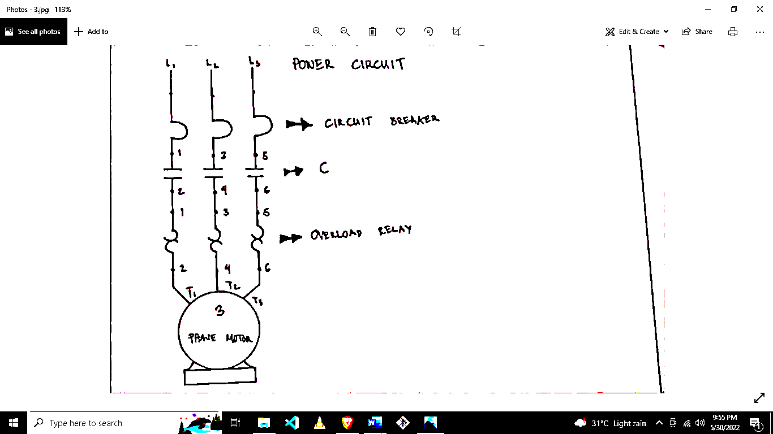

Circuit Breaker

C

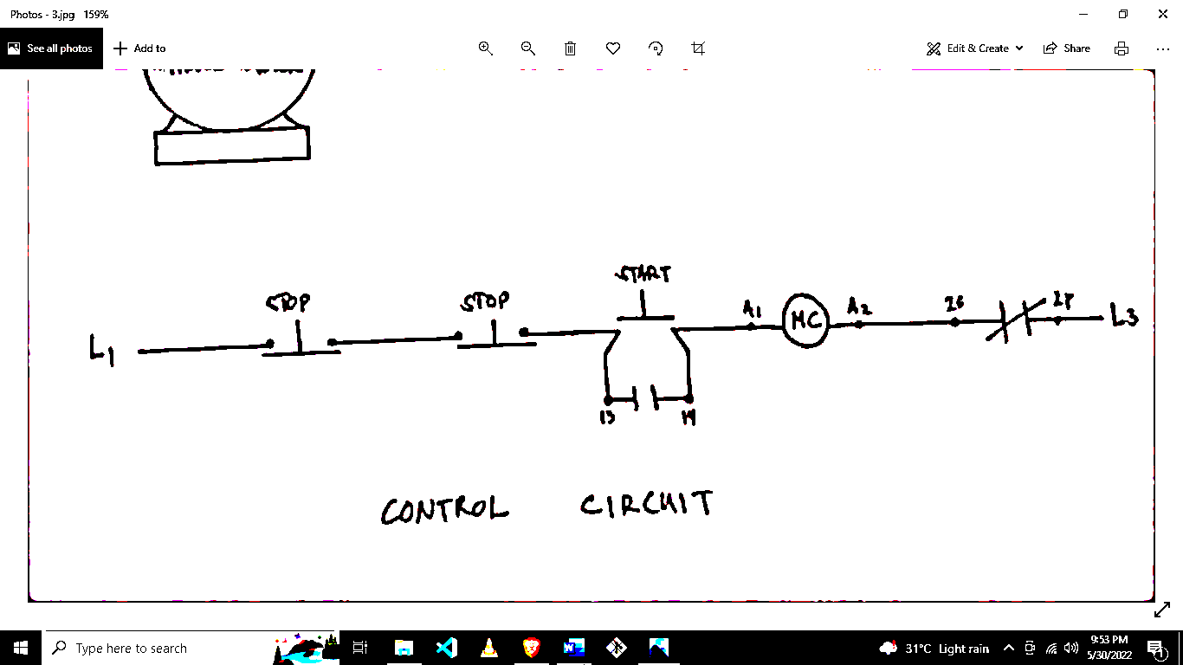

BEET 3C

Overload Relay

Checked By:

Rudy C. Docoy

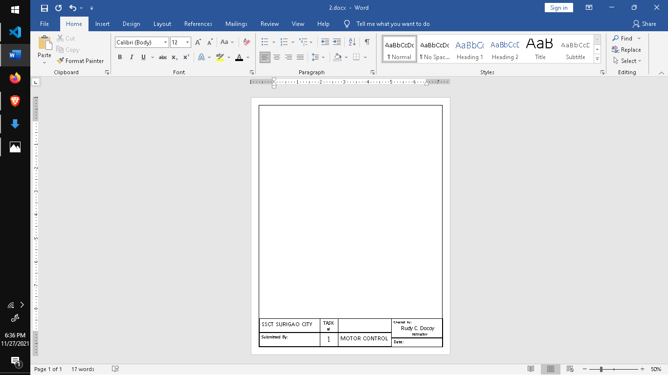

MOTOR CONTROL

**Date :**May 31, 2022



TASK #

3

SSCT SURIGAO CITY

Submitted By:

Control Circuit

Instructor

